**ASSIGNED PROBLEMS (Turn in for a grade)**

**14–13** A tank contains 21 kg of dry air and 0.3 kg of water vapor at 30°C and 100 kPa total pressure. Determine

(a) The specific humidity

(b) The relative humidity

(c) The specific enthalpy of the mixture in the tank as (kJ/kg-mixture) (calculate by hand)

(d) The specific enthalpy of the mixture in the tank as (kJ/kg-dry air) (calculate by hand)

(e) Explain (in 1-2 sentences) the difference between the values in c and d – which value agrees with the enthalpy value in the psychrometric chart at this condition?

**14–35** Atmospheric air at 35°C flows steadily into an adiabatic saturation device and leaves as a saturated mixture at 25°C. Makeup water is supplied to the device at 25°C. Atmospheric pressure is 98 kPa. Determine the relative humidity and specific humidity of the air.

**14–42** The air in a room has a pressure of 1 atm, a dry-bulb temperature of 24°C, and a wet-bulb temperature of 17°C. Using the psychrometric chart, determine

(a) The specific humidity,

(b) The enthalpy, in kJ/kg dry air,

(c) The relative humidity,

(d) The dew-point temperature, and

(e) The specific volume of the air, in m3/kg dry air.

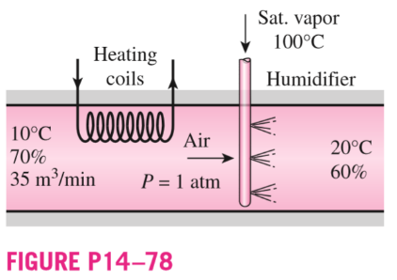**14–78** An air-conditioning system operates at a total pressure of 1 atm and consists of a heating section and a humidifier that supplies wet steam (saturated water vapor) at 100°C. Air enters the heating section at 10°C and 70 percent relative humidity at a rate of 35 m3/min, and it leaves the humidifying section at 20°C and 60 percent relative humidity. Determine

(a) the temperature and relative humidity of air when it leaves the heating section,

(b) the rate of heat transfer in the heating section, and

(c) the rate at which water is added to the air in the humidifying section.

**14–98** Air enters an evaporative cooler at 1 atm, 36°C, and 20 percent relative humidity at a rate of 4 m3/min, and it leaves with a relative humidity of 90 percent. Determine

(a) the exit temperature of the air and

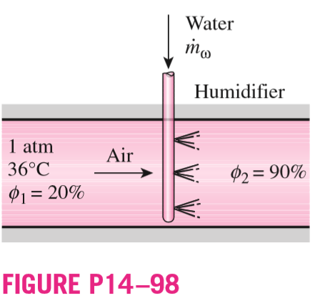(b) the required rate of water supply to the evaporative cooler.

**14–110** Two humid air streams are adiabatically mixed at 1 atm pressure to form a third stream. The first stream has a temperature of 40°C, a relative humidity of 40 percent, and a volumetric flow rate of 3 L/s, while the second stream has a temperature of 15°C, a relative humidity of 80 percent, and a volumetric flow rate of 1 L/s. Calculate the third stream’s temperature and relative humidity.

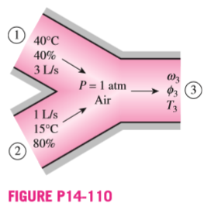

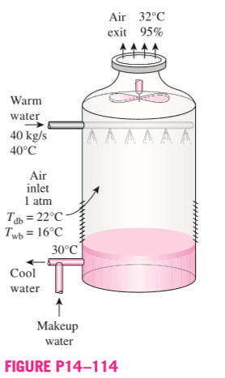**14–114** A wet cooling tower is to cool 40 kg/s of water from 40 to 30°C. Atmospheric air enters the tower at 1 atm with dry- and wet-bulb temperatures of 22 and 16°C, respectively, and leaves at 32°C with a relative humidity of 95 percent. Using the psychrometric chart, determine (a) the volume flow rate of air into the cooling tower and

(b) the mass flow rate of the required makeup water.

**SUGGESTED PROBLEMS: (do NOT turn the following in for a grade)**

C&B 8th Ed Chapter 14

Problems 2, 5, 17, 19, 28, 34, 35, 43, 54, 55, 66, 69, 77, 93, 94, 102, 105, 110